SIMATS ENGINEERING
ASSESSMENT TOOL III – VISUALIZATION CRITIQUE & REDESIGN
Course: Data Handling and Visualization | Code: DSA0601 | CO: CO3
Duration: 120 min | Total Marks: 100 | Reg No: 192424259
Name: P.Hemika

COURSE OUTCOME COVERED
CO3: Analyze time-series data, trends, associations, and uncertainty through appropriate visualization methods. (BL4) Activity Tool: Visualization Critique & Redesign Weightage: 20%

Code of Conduct:
I P.Hemika(192424259) certify that this submission is my original work and that I have adhered to the guidelines specified for this assessment. I understand that any violation of academic integrity rules will result in disciplinary action.

P.Hemika
Signature of the student: ______________________________
Criteria | Evaluation of Existing  Visualization  (25%) | Redesign  Strategy  (25%) | Application of Vis. Principles (20%) | Organization (15%) | Accuracy (10%) | Clarity  (5%) | Total
Q1
Q2
Q3
Q4
Q5

AT3 – Visualization Critique & Redesign
R Programming Assessment – Distribution and Proportion Visualization
Instructions: For each question, use R/RStudio to reproduce the given visualization, critique its effectiveness, identify misleading or inappropriate visual encodings, and redesign it using a more suitable visualization. Include the R code, redesigned visualization, and a concise justification of your design decisions.
Question 1 – Critique and Redesign an ECDF and Q-Q Plot
Dataset: Delivery_Time_Distribution.csv
Dataset:
Order_ID | Warehouse | Delivery_Time_Hrs
O01 | Chennai | 4
O02 | Chennai | 5
O03 | Chennai | 6
O04 | Chennai | 7
O05 | Chennai | 9
O06 | Bengaluru | 3
O07 | Bengaluru | 5
O08 | Bengaluru | 6
O09 | Bengaluru | 8
O10 | Bengaluru | 10
O11 | Hyderabad | 6
O12 | Hyderabad | 7
O13 | Hyderabad | 8
O14 | Hyderabad | 12
O15 | Hyderabad | 15
O16 | Pune | 4
O17 | Pune | 6
O18 | Pune | 8
O19 | Pune | 9
O20 | Pune | 22

Assessment Task
A logistics analyst has created an ECDF and a Q-Q plot to study delivery time distribution across warehouses, but the charts use inconsistent axis scaling, missing reference lines, and cluttered gridlines.
1. Create the two original-style plots in R.

Program:
START

Create dataset with:
Order_ID
Warehouse
Delivery_Time_Hrs

Extract all Delivery_Time_Hrs values

Set plotting area for two plots

Create ECDF plot:
Use Delivery_Time_Hrs
Set title as "Original ECDF"
Set x-axis label as "Delivery Time"
Set y-axis label as "Cumulative Proportion"
Use inconsistent axis scaling
Add gridlines

Create Q-Q plot:
Use Delivery_Time_Hrs
Set title as "Original Q-Q Plot"
Set x-axis as "Theoretical Quantiles"
Set y-axis as "Sample Quantiles"
Add gridlines
Do not add normal reference line

Display both plots

STOP

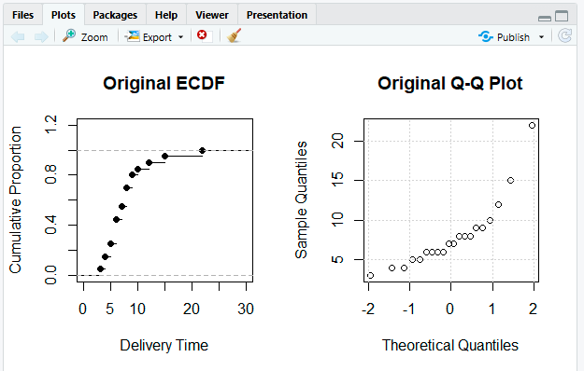
2. Identify at least three visualization problems.

Visualization Problems
- Inconsistent axis scaling: The ECDF uses an unnecessarily large range, making the data pattern less clear.
- Missing reference line: The Q-Q plot has no normal reference line, making it difficult to judge normality.
- Cluttered gridlines: Too many gridlines distract from the actual data points and curves.
- Unclear titles and labels: The plots do not clearly describe what distribution is being analyzed.
- Outlier is not highlighted: The unusually high delivery time of 22 hours is not easily noticeable.

3. Redesign the plots using appropriate scales, labels, reference lines, and minimal visual clutter.
Program:
data <- data.frame(
Order_ID = c("O01","O02","O03","O04","O05",
"O06","O07","O08","O09","O10",
"O11","O12","O13","O14","O15",
"O16","O17","O18","O19","O20"),
Warehouse = c(rep("Chennai",5), rep("Bengaluru",5),
rep("Hyderabad",5), rep("Pune",5)),
Delivery_Time_Hrs = c(4,5,6,7,9,3,5,6,8,10,6,7,8,12,15,4,6,8,9,22)
)

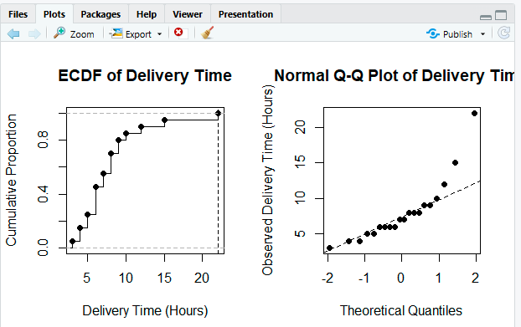
4. Explain how the redesigned plots improve interpretation of skewness, outliers, and normality.

How the Redesigned Plots Improve Interpretation
ECDF Plot:
The improved scale clearly shows that most delivery times are between 3 and 15 hours, while the value 22 hours appears at the extreme right, indicating a possible outlier. The step pattern also helps identify skewness because the distribution extends farther toward higher delivery times.
Q-Q Plot:
The reference line makes comparison with a normal distribution easier. If points follow the line, the data is approximately normal. Here, the extreme value of 22 hours is expected to deviate noticeably from the line, suggesting right skewness and departure from normality.

5. State whether an ECDF plot alone is sufficient to detect outliers, or whether it should be paired with another plot.

Is an ECDF Alone Sufficient to Detect Outliers?
No. An ECDF can show unusually large or small observations, but it is not sufficient by itself to reliably identify outliers. It should be paired with another visualization such as a boxplot or Q-Q plot. A boxplot is especially useful for clearly identifying outliers, while a Q-Q plot helps assess normality and extreme deviations.
Conclusion: The redesigned ECDF and Q-Q plots provide a clearer understanding of the distribution, showing possible right skewness, the extreme delivery time of 22 hours, and deviation from normality.

Question 2 – Critique and Redesign Many Distributions Using Bean Plots
Dataset: Subject_Marks.csv
Dataset:
Student_ID | Subject | Marks
T01 | Physics | 58
T02 | Physics | 63
T03 | Physics | 70
T04 | Physics | 77
T05 | Physics | 85
T06 | Chemistry | 52
T07 | Chemistry | 60
T08 | Chemistry | 68
T09 | Chemistry | 74
T10 | Chemistry | 82
T11 | Mathematics | 61
T12 | Mathematics | 66
T13 | Mathematics | 73
T14 | Mathematics | 80
T15 | Mathematics | 90
T16 | Biology | 55
T17 | Biology | 62
T18 | Biology | 69
T19 | Biology | 76
T20 | Biology | 88

Assessment Task
An academic report uses four separate boxplots with different y-axis ranges to compare marks across subjects. The comparison is difficult because the scales and layouts are inconsistent.
1. Reproduce the problematic visualization using R.
2. Critique the use of separate boxplots, inconsistent scales, and truncated axes.
3. Redesign the visualization using bean plots or a suitable violin/density-based alternative. 4. Add an appropriate common scale and clear subject labels.
5. Explain which subject has the highest concentration of marks and which subject shows the greatest spread.

Interpretation

Subject with the Highest Concentration of Marks
Mathematics has a strong concentration of marks around the middle-to-high range, approximately 66 to 80 marks, with the highest values concentrated toward the upper side.

Subject with the Greatest Spread
Biology shows the greatest overall spread in the distribution, ranging from 55 to 88 marks, giving it a range of 33 marks.
The redesigned bean or violin plot is better than four separate boxplots because all subjects use the same scale and can be compared directly. It also provides more information about the distribution shape, concentration, and spread of marks.
Program:
START
Create the dataset containing:
Student_ID
Subject
Marks
Separate the marks according to each subject:
Physics
Chemistry
Mathematics
Biology
Set plotting area for four separate plots
Create a boxplot for Physics:
Use a separate and truncated y-axis range
Create a boxplot for Chemistry:
Use a different y-axis range
Create a boxplot for Mathematics:
Use another different y-axis range
Create a boxplot for Biology:
Use another y-axis range
Display all four boxplots
STOP

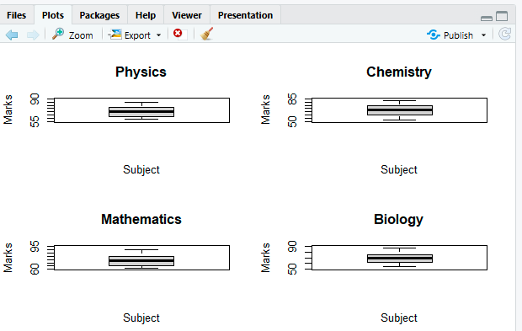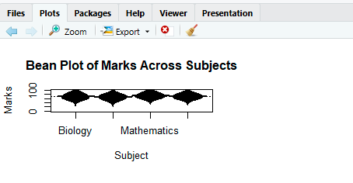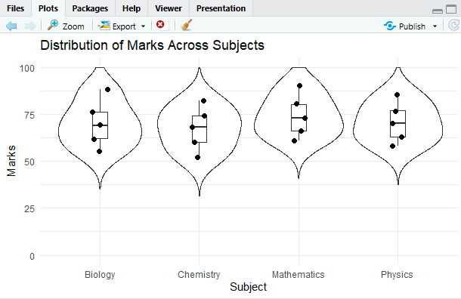
Question 3 – Critique and Redesign Proportion Visualizations
Dataset: App_Downloads.csv
Dataset:
City | App_Category | Downloads
Chennai | Games | 30

City | App_Category | Downloads
Chennai | Social | 42
Chennai | Utility | 18
Mumbai | Games | 35
Mumbai | Social | 38
Mumbai | Utility | 22
Delhi | Games | 26
Delhi | Social | 44
Delhi | Utility | 20
Kolkata | Games | 24
Kolkata | Social | 36
Kolkata | Utility | 29

Assessment Task
A marketing team presents app-category proportions using four pie charts, one for each city. The charts use exploded slices, mismatched color palettes, and inconsistent labeling.
1. Create a representative version of the misleading visualization.
2. Identify at least four design problems.
3. Redesign the analysis using side-by-side bars and a 100% stacked bar chart.
4. Compare the two redesigns and determine which is better for comparing city-wise proportions. 5. Explain why exploded pie slices and mismatched color palettes can lead to misleading conclusions.
Answer:
- Separate pie charts make comparison difficult because users must compare proportions across four different circles.
- Exploded or unequal slice sizes create visual exaggeration, making some categories appear more important than they actually are.
- Mismatched color palettes are confusing because the same app category has different colors in different cities.
- Inconsistent labeling makes interpretation harder because users cannot quickly identify corresponding categories.

Exploded Pie Slices
Exploding a slice gives it additional visual emphasis. A category may appear more important simply because it is separated from the pie, even if its actual proportion is not the largest.

Mismatched Color Palettes
Using different colors for the same category in different cities forces the viewer to repeatedly check labels. For example, if Games is red in Chennai but yellow in Mumbai, comparison becomes confusing and may lead to incorrect conclusions.
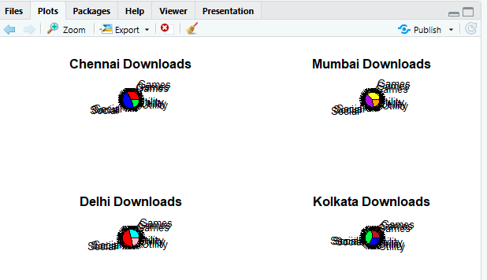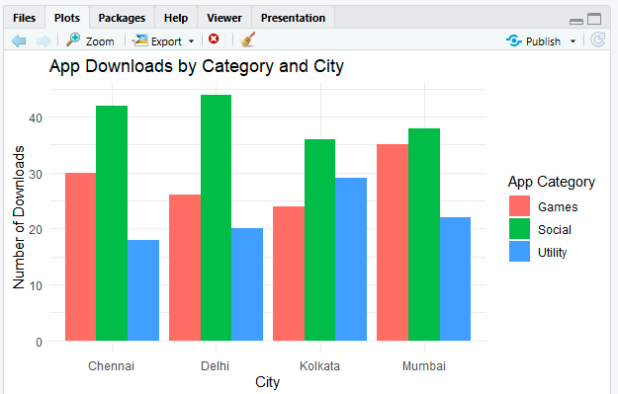

Question 4 – Critique and Redesign Nested Proportions
Dataset: Campus_Expenditure.csv
Dataset:
Campus | Department | Expense_Type | Amount
Campus A | Engineering | Faculty Salary | 62000
Campus A | Engineering | Lab Equipment | 34000
Campus A | Management | Faculty Salary | 28000
Campus A | Management | Guest Lectures | 15000
Campus B | Engineering | Faculty Salary | 54000
Campus B | Engineering | Lab Equipment | 40000
Campus B | Management | Faculty Salary | 24000
Campus B | Management | Guest Lectures | 17000
Campus C | Engineering | Faculty Salary | 66000
Campus C | Engineering | Lab Equipment | 31000
Campus C | Management | Faculty Salary | 26000
Campus C | Management | Guest Lectures | 19000

Assessment Task
A finance office uses a treemap to communicate Campus → Department → Expense Type spending. Small areas have unreadable labels and the color scale does not clearly communicate the hierarchy.
1. Create the original treemap.
2. Critique the size, labeling, color, and hierarchy encodings.
3. Redesign the visualization as an improved treemap.
4. Create a sunburst alternative and compare it with the redesigned treemap.
5. Recommend one visualization for a board presentation and justify your choice.

Critique of the Original Treemap

Size Encoding
The treemap correctly uses area to represent expenditure amount, but very small expense categories can become difficult to see and compare.

Labeling Problem
Labels in smaller rectangles may overlap or become unreadable, especially at the lowest level of the hierarchy.

Color Problem
If colors are assigned inconsistently, the viewer cannot easily understand which rectangles belong to the same campus or department.
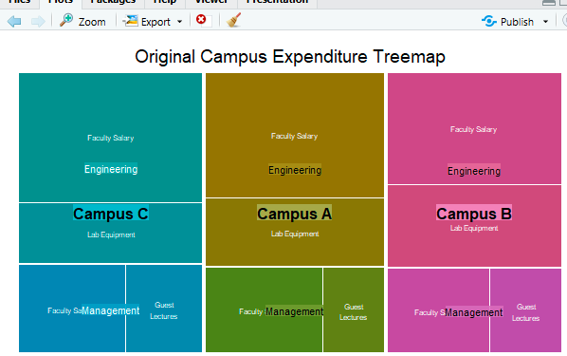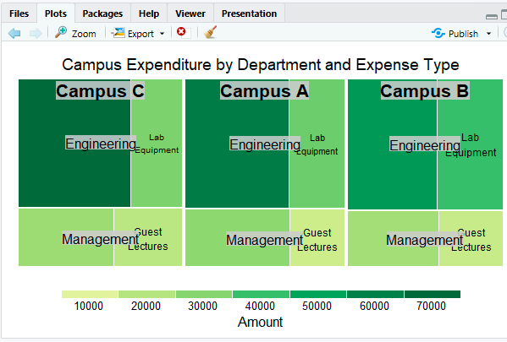

Recommendation: Redesigned Treemap
The redesigned treemap is recommended for a board presentation because expenditure amounts can be compared more easily through rectangle sizes. It uses screen space efficiently and clearly shows the three-level hierarchy: Campus → Department → Expense Type.
The sunburst chart is visually attractive and clearly communicates hierarchy, but comparing spending amounts using angles and curved segments is more difficult. Therefore, for a board that needs to quickly understand where the largest amounts are spent, the redesigned treemap is the better choice.
Question 5 – Critique and Redesign Flow-Based Proportions
Dataset: Course_to_Career_Flow.csv
Dataset:
Course | Certification | Job_Role | Students
Data Science | Yes | Analyst | 22
Data Science | Yes | Engineer | 14
Data Science | No | Analyst | 9
Web Development | Yes | Frontend Dev | 19
Web Development | Yes | Backend Dev | 11
Web Development | No | Frontend Dev | 7
Cloud Computing | Yes | DevOps Engineer | 17
Cloud Computing | Yes | Cloud Analyst | 10
Cloud Computing | No | Support Engineer | 6
UI/UX Design | Yes | Product Designer | 13
UI/UX Design | Yes | UX Researcher | 8
UI/UX Design | No | Product Designer | 5

Assessment Task
A training institute uses a Sankey diagram to show Course → Certification → Job Role. The original chart uses near identical colors, unlabelled flows, and node widths that are difficult to compare.
1. Create a Sankey diagram representing the data.
2. Identify at least four potential sources of confusion or misleading interpretation.
3. Redesign the Sankey diagram with meaningful labels, consistent flow representation, and an appropriate visual hierarchy.
4. Create a parallel sets alternative and compare the two designs.
5. Explain which visualization better communicates the major student career flows and why.

Potential Sources of Confusion or Misleading Interpretation

1. Near-Identical Colors
Using similar colors for different courses, certification groups, or job roles makes it difficult to follow the correct student flow.

2. Unlabelled Flows
Without values or clear labels, users cannot easily identify how many students move through each path.

3. Difficult Node Width Comparison
Node sizes and flow widths can be visually difficult to compare, especially when several flows overlap.

Which Visualization Better Communicates Major Student Career Flows?
The redesigned Sankey diagram better communicates the major student career flows because the width of each connection directly represents the number of students. Major pathways such as:
- Data Science → Certified → Analyst
- Web Development → Certified → Frontend Dev
- Cloud Computing → Certified → DevOps Engineer
can be identified quickly through their wider flows.

